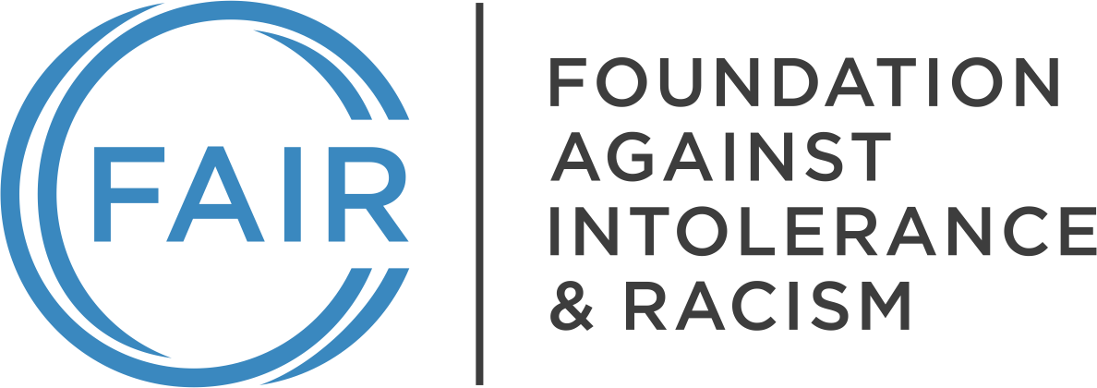

Month, Day, Year

Title/Name
Institution Name
Address
Dear [recipient name]:
The Foundation Against Intolerance & Racism (FAIR) is a nonpartisan, nonprofit organization dedicated to advancing civil rights and liberties and promoting a common culture based on fairness, understanding, and humanity. We have tens of thousands of members nationwide, including in [State]. Our website, fairforall.org, can give you a fuller sense of our identity and activities.
As a FAIR member and a parent within the [school name/district name] (the “District”/“School”), I write today in order to raise important considerations that must be accounted for in advance of the upcoming Pride Month activities, which will take place during the month of June. It is important that the District/School allow students to freely participate in the [event/protest/activities] in a manner that comports with their free expression rights. It is equally important that the District/School enforce its relevant policies in order to ensure that students who wish to abstain from participating are not subjected to bullying or harassment and do not otherwise feel compelled to participate.
The importance of public schools’ stringent protection of their students’ First Amendment rights cannot be overstated. When it comes to social, political, and ideological matters, public schools are charged with teaching students how to think, and with avoiding teaching students what to think. I would like to applaud the District/School for the many ways it allows students the freedom to explore and express their beliefs on important matters during this critical time in their personal development.
The principles of open inquiry and free expression derived from the First Amendment to the United States Constitution serve as an important pillar of a well-rounded public education. These foundational principles are clearly reflected in the relevant body of Supreme Court law. The First Amendment demands that public school students have a variety of ideas and information available to them, that students have the freedom to interact with and respond to ideas and information in ways that are not substantially disruptive to the learning environment, and that students are free to reject ideas and beliefs they do not hold. The important balance inherent in this body of law is what allows students to learn and freely express themselves in a safe educational environment.
I urge the District/School to closely review its existing policies in advance of the Pride Month activities to ensure they provide faculty and staff with the tools necessary to ensure a positive experience for all students where their First Amendment rights are honored and safeguarded. Furthermore, I ask that you consider issuing a District/School-wide communication that delineates the District’s/School’s policies and plan for ensuring the maintenance of a safe learning environment that protects all students.
Very truly yours,

[NAME]
[Chapter Name, Title]
Foundation Against Intolerance & Racism

cc: [consider cc’ing all school board members, and any known attorneys representing the school board]

See Board of Educ., Island Trees Union Free School Dist. No. 26 v. Pico, 457 U.S. 853, 864 (1982) (holding that the First Amendment prohibits public school boards from removing library books in an effort to “prescribe what shall be orthodox in politics, nationalism, religion, or other matters of opinion”), citing Tinker v. Des Moines School Dist., 393, U.S. 503, 506 (1969).
See Tinker v. Des Moines School Dist., 393, U.S. 503, 506 (1969) (holding that public school students’ free expression rights cannot be abridged unless the school can prove that such expression would materially and substantially interfere with the operation of the school).
See West Virginia State Bd. of Educ. v. Barnette, 319 U.S. 624, 642 (1943) (public school students cannot be required to recite the Pledge of Allegiance); see also Hurley v. Irish-American Gay, Lesbian, & Bisexual Grp., 515 U.S. 557, 573 (1995); Wooley v. Maynard, 430 U.S. 705, 714 (1977) (“A system which secures the right to proselytize religious, political, and ideological causes must also guarantee the concomitant right to decline to foster such concepts.”).

